InternVL2
Install Conda environment:
conda create -n intern-vl2 python=3.11 -y && conda activate intern-vl2

Install required libraries:
pip install lmdeploy

pip install modelscope
pip install huggingface_hub
pip install timm

Download the Model;
- download from Hugging face (https://huggingface.co/OpenGVLab/internVL2-8B)
from huggingface_hub import snapshot_download
model_dir = snapshot_download(repo_id="OpenGVLab/InternVL2-8B", local_dir = "/home/modelscope/shan/InternVL2-8B/model-files")

- Download from Modelscope (https://modelscope.cn/models/OpenGVLab/InternVL2-8B)

from modelscope import snapshot_download
model_dir = snapshot_download("OpenGVLab/InternVL2-8B", local_dir = "/home/modelscope/shan/InternVL2-8B/model-files")

- download from Modelscope using command line
create account and login
>> modelscope login --token 120ffdc5-1efb-400c-a8fb-e5789ce0985a
>> modelscope download --model OpenGVLab/InternVL2-8B --local_dir InternVL2-1B/model-files

My Server GPU
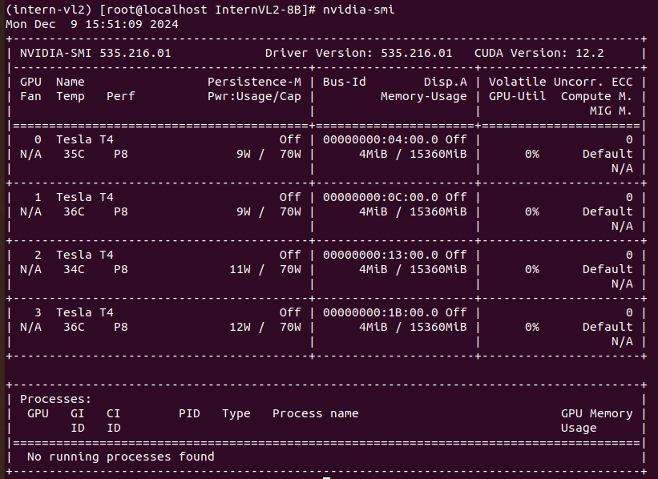

CUDA: Out of memory

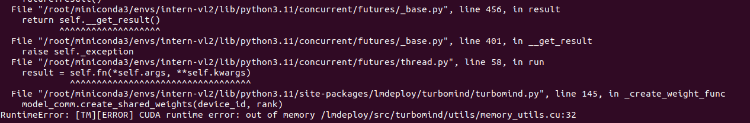

Reference:
https://internvl.readthedocs.io/en/latest/internvl2.0/quick_start.html
https://modelscope.cn/models/OpenGVLab/InternVL2-8B/summary
https://github.com/OpenGVLab/InternVL
https://huggingface.co/OpenGVLab/internVL2-8B

